WebEx Navigation and Tips for Students Using JAWS or NVDA

Navigating this document
- This document is organized using headings and tables. Press H to navigate through headings.
- Press T to move to the tables. To navigate within the tables, use Alt + Ctrl + Arrow keys.

Basic Recommendations
- Use a headset microphone and plug it into the computer before launching the meeting.
- Using a headset will allow for better audio and will also ensure that the sound of your screen reader is not heard by your instructor or classmates.
- For the best experience download the WebEx App rather than using the browser version.
- If you have trouble navigating WebEx with your screen reader, please contact the ATI for assistance.

Quick Keys
- Microphone Mute/Unmute: CTRL + M
- Navigate between Content Area and Participant Panel: F6
- Raise Hand: Navigate to the participant panel then Tab to raise hand.
- Toggle meeting controls press Ctrl + Shift + Q.

Join and Leave Meeting
Task | Instructions
Join Meeting  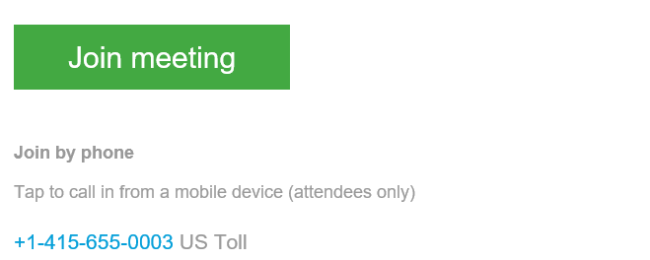  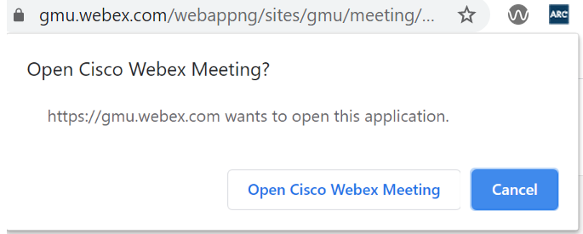  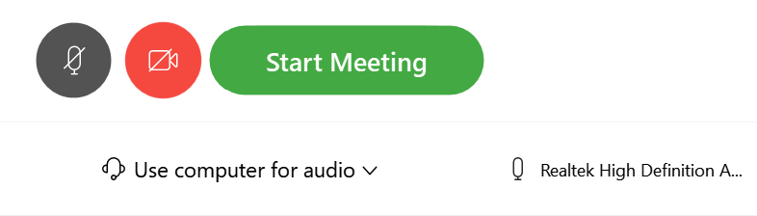 | Your professor will post a link to the class session. Check with your professor to determine where to find the link. (Select the link).  If you need to connect using just your phone:  dial: 415-655-0003 and use the Access Code provided in the meeting invite to enter into the meeting.  If this is the first time you are joining a meeting, you may be asked if you would like open in the WebEx App. This is highly recommended if you use JAWS or NVDA.  Tab to the Start Meeting Button
Leave Meeting  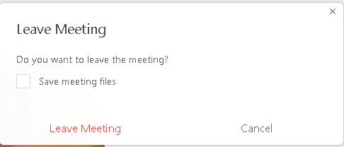 | If you need to exit the call, press F6 until you are in the content panel Then use the tab key until you get to the Leave Meeting button.  From the content panel you can also go to the file menu and then Press L for Leave Meeting

Navigating Inside the WebEx Session
Inside the meeting there are two main areas, the Content Area and the Panels Area. When using the WebEx App Press F6 to move quickly between these two areas.
In the Panels area use Ctrl + Tab to move the cursor focus between Participant Panel and Chat Panel
Use Tab to move to options within the participant and chat panels
To focus your cursor on the tools in the Content Area press Ctrl + Shift + Q. This will toggle the meeting controls on and off. Press it repeatedly until you here the state of the mute button. This will indicate that you are in the Content Area and on the meeting controls at the bottom of the screen. Use Tab to move through the buttons.

Content Area Tools
The Content area is where you instructor will share their PowerPoint, screen or video. Tools in this area include: microphone, camera, share content, record, open participant panel, open chat panel, Options and Leave Meeting. See tables below for more information.
To toggle display meeting controls on and off, press Ctrl + Shift + Q.
Use the Tab key to navigate in your app, use Shift + Tab to navigate back through Tools.
Use the Spacebar or Enter to select items.
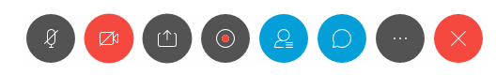
Tool | Description
Microphone | Ctrl M: Toggle microphone from mute to unmute (You will hear one beep when the mic is muted and two beeps when it is unmuted). Mute/unmute is the first item in the Content Area. The cursor focus will be focused on it when navigating into the Content Area.
Camera | Share video camera tool is the second item in the tool menu. Share video will display your camera to students in the class.
Record | The record tool is the third item in the tool menu. You may not have access to this tool as a student unless your professor has given you access to it.
Share | Share content is the fourth item in the tool menu. It allows you to share your screen or documents. You will not be able to share unless given permission by your professor.
Participants | Open and close participant panel is the fifth item on the tool menu. This will open the participant panel. The participant panel lists all of the participants in the meeting and allows you to interact by raising and lowing your hand.
 | Open and close chat panel is the sixth item on the tool menu. This will open the chat panel where you can type a message to the instructor, the entire class or individual participants.
 | More options button allows you to adjust settings.
 | Leave meeting is the last item in the menu. It will allow you to leave the meeting. It does not end the meeting, only the professor is able to end the meeting.

Panel Area
The panel area includes the Participant Panel and the Chat Panel. Press F6 to move between the Content Area and the Panels area. Once in the Panel area, press
Tool | Description
Participants | Use the Participant Panel to view the list of attendees logged in to your class. Press the tab key to move through options including raise and lower hand. Use up and down arrows to move through the participant names.
Raise Hand | There is no shortcut key to raise and lower your hand in WebEx, Use F6 to get to the participant panel, tab to your name and tab to raise hand.
Chat Panel | Use Chat to chat with your professor or specific participants in your class.  Use the drop-down menu to select who you would like to include in your chat.

Resources
Navigate WebEx Meetings with your keyboard

