Blackboard Ultra: Basic Navigation and Tips for Students Using JAWS or NVDA

Navigating this document
- This document is organized using headings and tables. H to navigate through headings.
- Press T to move to the tables. To navigate within the tables, use Alt + Ctrl + Arrow keys.

Basic Recommendations
- Use a headset microphone and plug it into the computer before launching the session. Using a headset will allow for better audio and will also ensure that the sound of your screen reader is not heard by your instructor or classmates.
- For the best experience with a screen reader, use the Chrome Browser
- If you have trouble navigating Blackboard Ultra with your screen reader, please contact the ATI for assistance.

Quick Keys
- Microphone Mute/Unmute: ALT + M
- Raise Hand ALT + H

Join and Leave Session
Task | Instructions
Join Session  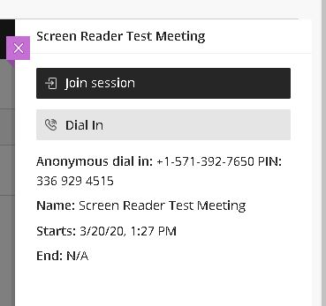 | Your professor will post a link to the class session on blackboard. Check with your professor to determine the location of the link within your course.  Select the link.  Tab to the Join Session button it will appear on the right side of the screen. (Join session notification: Sounds like a boing)  If you need to join using your phone, the number and Session PIN is provided below the Dial In button.
Leave Session  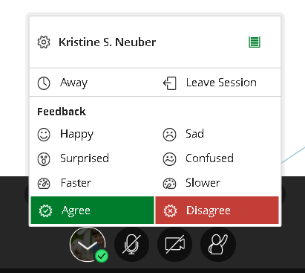 | This will disconnect you from the meeting.  Go to the My Status button  Press the space bar to open the menu  Use the arrow keys to move to Leave Meeting and Press Enter.

Navigating Inside the Session
Inside the session there are two main panels areas. The Content Area or Region and the Collaborate Tools. These two areas have their own set of tools described in the tables below along with more efficient navigation keystrokes.
To move to the content area, press R. This will bring you to the shared content such as a Power Point Presentation shared by your professor. To quickly move to the Collaborate Tools use Insert F6 to get a list of headings and choose Participant.

Content Area Tools
Press R to navigate to the Shared Content Region. This is where you instructor will share their PowerPoint, screen or video. Tools that appear in the content presentation area relate directly to what is happening in the session at that moment. They include my status, microphone, camera and raise hand. See tables below for more information.
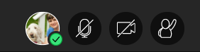
Tool | Description
My Status | My status allows you to notify your instructor that you are away or leave the session. It will also allow you to provide feedback such as Happy, Sad, Surprised, confused, faster, slower, agree or disagree. Your status will display on the participant list next to your name.  Press R to get to the shared content region then press tab to get to My Status. Once on my status use the space bar to open and then arrow keys to navigate through options.  Use the Tab key until you reach the My status button. It is two tabs from the session menu button. Once on my status use the space bar to open and then arrow keys to navigate through options.
Microphone  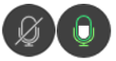 | Press Alt + M to turn your microphone on and off.  Mute: Sounds like a series of notes from high to low.  Unmute: Sounds like a series of notes from low to high.
Camera | Press Alt + C to turn your camera on and off.
Raise Hand | Press Alt + H to raise or lower your hand. Your professor will see your hand raised in the participant list next to your name.

Collaborate Panel Tools
Ensure that the Collaborate Panel is open:
Press B to move to the Open Collaborate Panel button if it is closed, press enter to open it. The Collaborate panel has the following tab panels: Chat, Attendees, Share Content and My settings. Once focused on the Collaborate Panel, use the up and down arrow keys to move through the tool tabs.
Tool | Description
Chat | Use Chat to chat with your professor or specific participants in your class.  Use the drop-down menu to select who you would like to include in your chat.
Attendees panel | Use Attendees Panel to view the list of attendees logged in to your class. Press the tab key to move through options. Select: Access List of Attendees. Then use up and down arrows to move through attendees
Share Content | Use Share Content to share documents or your screen with the class. Professors have to give permission for you to share.  Press Tab key to cycle through options within the Share content tool.
My Settings | Use My settings. Here you can add a profile image, set up your audio and video and your notifications.

Interacting with Polls
Professors may ask you to complete a poll to get your opinion or test your understanding of a topic. After the professor starts a poll your cursor focus is often focused on the second choice in the poll, press Shift Tab to move the cursor up. Use the tab key to cycle through the choices and press Enter to select your choice.
Keyboard Navigation for Blackboard Collaborate Ultra

