Navigating Blackboard Tests with Dragon Professional

General Notes:

- If using Chrome be sure to install the Dragon Web Extension for increased functionality
- Dictating into HTML editor boxes provided for Essay and Short Answer question types can be very difficult, with limited ability to edit content once edited.
- Mouse Grid does not work consistently in Lockdown Browser (especially when using the camera option).
- Dragon commands works well to set up the camera option in Lockdown Browser

Commands for Navigating within a test
- Mouse Grid will allow you to move the mouse quickly within a grid that pops up on the screen note: Mouse Grid does not work consistently in Lockdown Browser (especially when using the camera option).
- Mouse Up and Mouse Down along with Faster or Slower to adjust speed once the mouse is moving. Once the mouse is positioned where you want it say “Stop” then “mouse click”
- Say “Tab Key” also works but there are often several tab stops before getting to the location desired and the cursor focus is hard to see. It is easy to get lost.
- Say “Click”… followed by the name of the answer you want to select in a question type. More details about navigating question types are listed below.
- Buttons like Submit or save answer can be selected by saying the name of the button, once focused on the button, say “Press Enter”or “Press Space” If there are several answers or buttons with the same name you will see a number next to the choices. Say “Choose” and then the number that corresponds with the option you want to select.

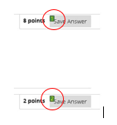

Essay Questions and Short Answer
To get to the edit box for essay questions use the mouse. – Mouse grid is the quickest way, but you can also use mouse up and mouse down and say faster or slower to adjust speed.
Issues:
- When dictating within the edit box, the text goes away and comes back. This appears to be due to the scroll bar within the edit box provided. “Scroll up” will work, but it is very disorienting. The user may be concerned that the text did not get entered the box.
- Editing within the text window provided was not easily done. Many editing commands do not work within the HTML edit box. For example: “select…” to highlight words to make a correction. However “Go to End of Line” and “Scratch That”(directly after dictating) did work properly.

Either/Or Questions and Multiple Choice (Radio Buttons)
Say “Click and then the name of the choice you want to select. For example, “Click True” or “Click False”. The radio button next to your choice will be selected.
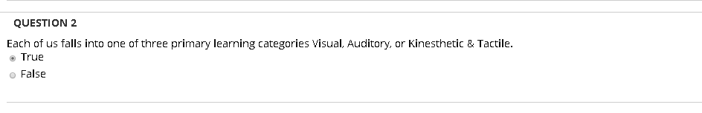

Multiple Answer (Checkboxes)
Say Click and then the name of the choices you want to select. For example, in the example below saying Click Visual/spatial” then “verbal/linguistic” will select the boxes next to your choice.
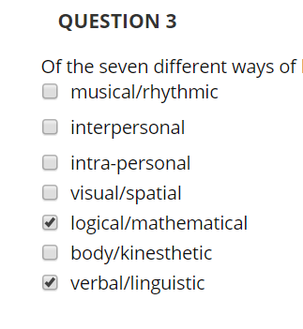

Match Question Items (Dropdown Options)
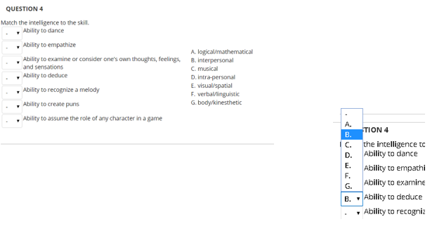
Say Click and then the name of the choice you want. -- Say “Press Enter” to open the dropdown -- Say “move down one” or “move up one” until you get to the choice you want – Say “Press Enter” to select.

